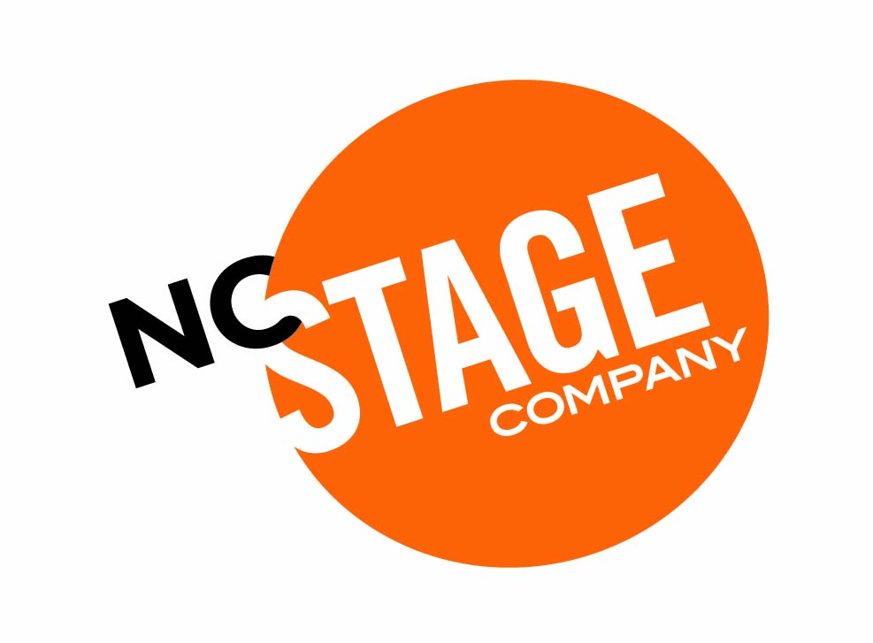
Win a trip to
New York City
for two!
Only 500 tickets will be sold at $30 each.

The drawing will take place on April 19, 2015 after the North Carolina Stage Company and Immediate Theatre Project production of An Iliad. The trip includes round trip coach airfare for two from Asheville to New York departing anytime between May 1, 2015 and July 31, 2015 and a three-night stay in a four-star hotel. The package also includes two tickets to Stalking the Bogeyman* (which had its world premiere at North Carolina Stage Company) and a $500 gift card for other expenses.
*Or your choice of another play of comparable value and also subject to Stalking the Bogeyman still playing at the time of your trip.
This is a fundraising project and all ticket sales benefit the North Carolina Stage Company. Tickets may be sold to employees, Board Members and other affiliated persons. You need not be present to win. An independent accounting firm will supervise the entries and drawing. If 200 tickets are not sold, a full refund will be provided and the raffle will not occur. North Carolina Stage Company is a North Carolina 501(c)3 corporation registered with the Secretary of State.

TO BUY TICKETS:
ONLINE: Order via our secure server at ncstage.org
BY PHONE: Call 828-239-0263, Monday through Friday, Noon to 5:00 PM.
BY MAIL: Send a check for $30.00 with the completed form below to:
North Carolina Stage Company Raffle • 15 Stage Lane • Asheville NC 28801

You will receive an official entry certificate by return mail for your records.
Name: _________________________________________________________________
Address:________________________________________________________________
City:____________________________________ State:_________ Zip:______________
Phone:________________________________________
Email:_________________________________________
# of tickets ______________ X $30.00 = ______________________
Check enclosed or charge my credit card: Amex MasterCard Visa Discover
Card #__________________________________ Exp: ___________________
Signature _______________________________________________________

