

**WELCOME TO NC STAGE’S VOLUNTEER USHER PROGRAM**

**GUIDELINES FOR NC STAGE USHERS**

Welcome to our Volunteer Usher Program at NC Stage! We have been producing professional theatre in Asheville for over 15 years! We are dedicated to creating theatre that is as consequential as entertaining.

NC Stage Volunteer Ushers make up the largest part of our staff, over 100 members strong! You are the first face that a patron sees when attending a play and your friendly, knowledgeable personality ties together the entire experience of our guests. We cannot thank you enough for all of your ongoing support. We could not do it without people like you!

**CONTENTS**

General Important Information………………………………………………………………………………………………… 2

Dress Code, Scheduling, Performance Procedure…….……………………….……………….…………………….. 3

Courtesy, Arrival, Usher Badges, Belongings, Usher Assignments……………………………………………...4

Seating Chart, Patrons in Wheelchairs, Seating Problems………………………………………………………….7

Taking your seat, During the Performance, Intermission, After the Show………………………………….9

Parking, Emergency Procedures……………………………………………………………………………………………… 10

1

**GENERAL IMPORTANT INFORMATION**

**HOUSE RULES**

**CAMERAS AND RECORDING DEVICES** cannot be used inside the theare. If you see a patron with a camera or recorder, politely inform them that photography and recording of any kind are not permitted in the theatre. If a guest takes a photograph inside the theatre, please notify the House Manager immediately.

**CELL PHONE AND TEXTING DEVICES** must be turned off or silenced (not put on vibrate) during the performance. If you see a patron on their phone inside the theatre politely ask them to turn it off. Only address a patron once.

**CONCESSION ITEMS ARE ALLOWED** inside the theatre, however outside food is not. **There is no glass permitted inside the theatre.** If a patron has a beverage in a glass bottle, please direct them to Concessions to obtain a plastic cup.

**ASSISTANT LISTENING DEVICES** are available to guests at the Visitor Service Desk. This service is free, but we do request that patrons leave a form of ID (Driver’s License, Cell Phone) until the device is returned. Each device and box is marked with a number, please put the ID in the box of the handed out device.

1. Patrons without a hearing aid: Hand out receiver unit and turn it on.
2. Patrons with a T-Coil: NO RECEIVER UNIT NEEDED OTHER THAN THEIR OWN HEARING AID. Please tell them to set their hearing aid to the T-Coil setting.
3. Patrons with a hearing aid but without the T-Coil function: Hand out receiver unit and turn it on. **Please tell them their hearing aid must be turned off** or it will feedback**.**

**Season Brochures** are available for guests at the Box Office and the Visitor Service Desk.

**THE BOX OFFICE** is open Monday- Friday from 12-5pm. On show days the Box Office opens 2 hours prior to the performance.

**REPORT IMMEDIATELY TO THE HOUSE MANAGER** any accidents, sick patrons, restrooms out of order or out of supplies, photos taken while the show is in progress, etc.

**ANY SUSPICIOUS CHARACTERS** should be reported to the House Manager immediately.

2

**DRESS CODE**

The Usher dress code is extremely helpful in a number of ways. Not only does it present a professional appearance, but it also assists patrons in identifying who they can ask questions and to go to in case of an emergency. It is also very helpful to the House Managers to quickly spot an usher if additional help is needed. We appreciate you arriving in the dress code each time you usher.

**Dress Code for Men:**

Solid white, collared shirt that buttons down the front – either short or long sleeved.

Black dress pants (No Jeans)

Solid black, **CLOSE-TOED** comfortable shoes (No sandals)

Solid black sport coat or sweater is optional

**Dress Code for Women:**

Solid white shirt – either short sleeved or long sleeved.

Black skirt or pants (No jeans)

Solid black, **CLOSE-TOED** comfortable shoes (No sandals)

Solid black blazer or sweater is optional

IF YOU’RE NOT DRESSED PROPERLY, YOU WILL NOT BE ABLE TO USHER OR ATTEND THE PERFORMANCE.

**USHER SCHEDULING**

The Audience Relations Manager will send you an email about three weeks before a show opens with the usher dates. Please respond with three availabilities to give flexibility in the scheduling process.

If you are a group of people that prefers to usher together, please include (cc) everyone involved in your first email and provide three possible dates.

Your date will be confirmed immediately, however a google drive schedule will be available to all ushers a week before the show opens.

3

In case there are any usher slots left closer to the opening date, you will receive a second email with the remaining dates. At this point you can sign up for a second usher shift.

If the schedule is full and not everyone received a spot there will be a “Waiting list” at the bottom with contact information. Please contact these people in the order listed if you have to cancel your usher date. Please send an email to [nina@ncstage.org](mailto:nina@ncstage.org) if you found someone to cover your shift and we will change it in the schedule.

**PERFORMANCE PROCEDURES**

**COURTESY**

We appreciate our ushers’ upbeat and pleasant behavior towards our guests and staff. Please continue to greet each patron with a kind “hello” and offer to assist them. Make yourself available to all guests who may have questions and offer any additional assistance necessary. It is also very helpful to phrase things in a positive way. For example, if they have found themselves in the wrong section of the theatre, say “Your seats are in the next section” and offer to walk them over to the correct section, rather than saying simply “You are in the wrong section.”

Patrons will naturally bring their questions to you. If you don’t know the answer, please tell them you will find out immediately. You should contact the House Manager and then get back to the Patron as quickly as possible with the answer. Patrons will also bring suggestions and complaints to you. Please listen to them carefully and sympathetically, thank them for making us aware of the situation, and indicate that you will convey the information to the House Manager immediately. These suggestions and complaints are very valuable in helping us assure the safety and comfort of our audience.

**ARRIVAL**

|  |  |  |
| --- | --- | --- |
| **PERFORMANCE TIME** | **USHER ARRIVAL TIME** | **DAYS APPLICABLE** |
| 2:00 pm | 1:00 pm | Sat. & Sun. Matinee |
| 7:30 pm | 6:30 pm | Tuesday – Saturday Evening |

Please arrive on time. Ushers who arrive more than 30 minutes late will be sent home and released from their Usher commitment.

4

The House Manager will do their best to assign you to the position you request but it cannot be guaranteed. We appreciate you trying all of the different ushering positions so that if we ever become short-handed, we know you can easily take on a different responsibility.

Only ushers who have attended an NC Stage Usher Orientation may usher at NC Stage theatre. This means you cannot bring friends to usher with you or send a substitute in to usher for you if you cannot make it. Also, ushers cannot check in for each other. Each individual usher must check in with the House Manager prior to receiving an usher badge.

Please be aware that we keep an attendance record for all ushers. Anyone with 3 last minute cancellations may be released from their ushering commitment for the rest of the season, and will not be invited back for the following season. It takes many ushers to operate our theatre and we appreciate as much advanced notice as possible if you are unable to make your ushering date. If you need to exchange your usher date, please do so at least 48 hours before your assigned date.

**USHER BADGES**

Please let the Box Office Associate know of your arrival, she will point you in the House Manager’s direction. The House Manager will take you in the designated room and you will receive the usher badge and a flashlight (if needed).

**COATS AND PERSONAL BELONGINGS**

Coats and umbrellas may be placed in the stage manager’s office. There are no lock-up facilities for valuables. If you must, bring a small purse or bag with you to keep on your shoulder while ushering. NC Stage is not liable for lost or stolen items.

**ONCE YOU ARRIVED**

Once you arrived and checked in with the House Manager, please refrain from eating, and making phone calls. Put away your coat and use the restroom before it is time for the Usher Speech. While you are waiting for the House Manager to give the speech please feel free to read the program for the performance so that you can answer more in depth questions our guests might have. Please refrain from reading and doing crossword puzzles, etc. once the theatre is open for seating.

We appreciate your availability to assist our guests as soon as you have signed in. Once you are assigned a particular job, please head to your station.

5

Direction Givers inside the theatre should go into the theatre to stuff programs, become familiar with the seating and await the Usher Speech. All program stuffing must be done inside the theatre. The House Manager will let you know how many are needed for the specific day. The programs should be stacked neatly in the baskets.

The Lobby Direction Giver will go to their station as soon as the House Manager has finished the Usher Speech. Please assist the patrons in any way possible, have an eye on the downstairs bathrooms and tell them about the upstairs option.

**USHER ASSIGNMENTS**

Theatre Direction Giver (2):

-You will stuff the programs.

-Help people to their seats. It is not feasible to physically bring each patron to their row, so be very specific as to where the patron should go.

-Hand out the assisted listening devices (more to that on page 2 ).

-Make sure patrons are not stepping on the stage or taking pictures.

-Guide patrons that need to use the bathroom during the show out of the theatre.

-Help with the clean up after the performance.

Lobby Direction Giver (1):

-Welcome Patrons into the theater and provide guidance .

-Keep an eye on the bathrooms and advice them to use the upstairs bathrooms as well (if applicable).

-Help our Concessions Manager to keep up with the water carafes; water hook up is in the kitchen. Before and during intermission.

-Guide people to the upstairs bathrooms to break up the line.

-After the performance help with the theatre clean up.

6

**SEATING**

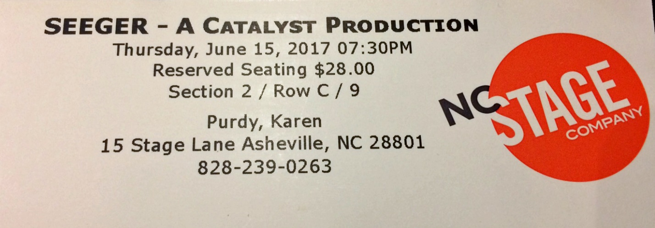

NC Stage has seating in three price sections available. Section 2 is the most expensive one followed by the pink section and yellow at the lowest price point.

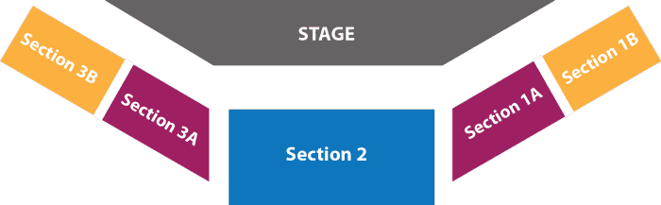

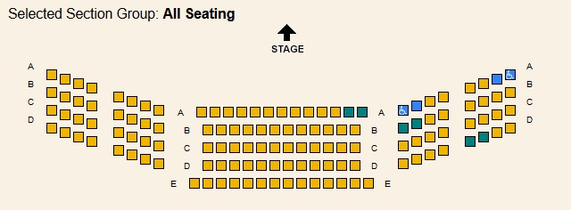

7

**GENERAL SEATING GUIDELINES**

1. Be aware when guests are entering the theatre.
2. Greet the guests and offer to assist them.
3. Escort the guests to their row if needed.

**Safety**: Try to be sure that your guest can handle the steps. If needed offer your arm to guide and support the guest. Use your flashlight to help the guests see where they are going and walk at a moderate pace so that the guest can easily follow you.

**Patrons in wheelchairs**: Will have tickets for Section 2 A9 or Section 1A A8. These seats can be removed. The patron can choose to stay in their wheelchair or transfer to the seat we provide. The House Manager will review with you where removed chairs should be stored in the theatre. This is also where walkers, scooters, crutches and the removable chairs can be stored. If a patron comes to the theatre in a wheelchair and needs wheelchair accessible seating, please get the House Manager to see if we have wheelchair accessible seating available.

**.**

**Seating Problems**

1. If you think you have double booked seats: Check both patrons tickets and assure that they are in the correct seats, on the correct date and time. If someone was seated incorrectly or is at NC Stage on the wrong date, politely correct the seating issue, or alert the House Manager.
2. If you legitimately have a case of duplicate seating (two patrons with tickets for the same seat): Alert a House Manager immediately. (Most likely one of the guests may have exchanged their tickets and brought the incorrect tickets.)
3. If a guest is unhappy with their seat due to it being uncomfortable; the view is obstructed, noisy guests around them, etc.: Do not promise any solution. Let the guest know that you are getting the House Manager and they will do everything possible, as quickly as possible, to try to remedy the situation.
4. Patrons that arrive late can be seated in their purchased seats all the way through the curtain speech. The Late Seating Break is a specific moment in the play (chosen by the director) when it is okay to seat late guests**.** THE HOUSE MANAGERS WILL SEAT ANY LATE GUESTS ONCE THE SHOW HAS STARTED.

8

**TAKING YOUR SEAT**

Please sit only in the assigned usher seats. It is very important that you do not move the chair for the safety of our actors and your own. It also makes you visible to our patrons and you have a good overview of the sections in case of an emergency.

**DURING THE PERFORMANCE**

While you watch the performance, enjoy the play, but also try to be aware of anything amiss in the theatre. You are closest to the scene of action and should alert the House Manager immediately should anything happen: accidents, illness, noisiness, camera flashes, cell phones, texting, etc. All of these are important and should be reported immediately. This will enable the House Manager to address the problem and leave you free to enjoy the play. The two Ushers seated by the entrance take turns in guiding the patrons out of the theatre in case the patron needs to use the bathroom or wishes to leave. The House Manager will guide them back to their seats if they wish to do so.

**INTERMISSION**

The Lobby Usher should return to the lobby immediately and help guide people to the rest rooms as well as to help the Concessions Manager with the water carafes.

Theatre Ushers should keep an eye on the stage, answer questions etc. Accesibility devices (cane, walker, wheelchair or any other mobility devices) should be returned to their owner if needed.

**AFTER THE SHOW**

One Usher will say “Goodbye” with the House Manager and collect programs (only if they wish to recycle). The other two will start with the clean-up, flipping up the chairs and collecting trash and programs.

Accessibility Devices: Be sure that all walkers, canes, etc. are returned to the patrons to whom they belong.

ALL USHERS MUST STAY IN THE THEATRE UNTILL ALL PATRONS HAVE SAFELY EXITED.

Once the theatre is clear of patrons, turn in your badge and flashlight with the House Manager.

9

**PARKING**

North Carolina Stage Company is conveniently located near two city-owned parking garages: the Rankin Avenue garage and the Civic Center garage.  Both charge an hourly rate ($1.25/hour), though the first hour is free.

You can often find street parking at metered spots in downtown Asheville, but be prepared to spend a little extra time during peak hours, such as Friday and Saturday evenings or during large tourism events.

**NORTH CAROLINA STAGE COMPANY EMERGENCY PROCEDURES**

**MEDICAL EMERGENCY**

Report immediately to the House Manager any kind of medical emergency, accident, illness whether great or small. The House Managers have experience handling these matters – please defer to them. The House Manager has a First Aid Kit and will contact 911 if necessary.

**WEATHER EMERGENCIES**

**Before shows take place** – In case of a weather emergency, NC Stage will announce show delays or cancellations on its website at [www.ncstage.org](http://www.ncstage.org) and will have a recording with the same information on the sales office phone line , (828) 239- 0263. In the instance of any dangerous weather, including tornadoes, earthquakes, storms, or power outages, follow the House Management and NC Stage staff instructions on what to do.

**When a show is taking place** – If there is weather emergency when a show is taking place or after a show is over, the House Manager will make an announcement. When weather emergencies take place during a performance, NC Stage will remain open until it is safe for patrons and staff to venture outdoors.

**FIRE EXITS and EMERGENCY EVACUATION PROCEDURES**

Please be sure to note where the fire exits are – some doors marked “EXIT” are for the general public, and some would only be used in case of an emergency. Please make sure no one uses the fire exits except in the case of an emergency. Patrons should exit through the lobby doors during performances. The House Manager will review the exits in each theatre during the usher speech and will point out which are for general use and which should be used only in case of an emergency.

10

If there is a fire emergency, an alarm will go off. Ushers should take position at the bottom of the stairs to monitor the traffic and to prevent people from running or falling. The House Managers will open the doors of the theatre. Once outside the building, ushers and NC Stage Staff Members will guide people across Walnut Street into the private parking lot. Please encourage patrons and fellow ushers to move away from the building quickly instead of turning around to see what is happening (this slows traffic). Do not stop until you have crossed the street. Be sure to follow instructions given by NC Stage House Manager and other NC Stage staff members.

**NC Stage Fire Exits**

There are two ways to exit NC Stage. The first one is the way you came into the theatre through the Lobby and out to Stage Lane the second one is behind the stage and has a staircase that allows access to Haywood St. Please note that the Haywood access should ONLY be used in case of emergency.

11